Soil Moisture Sensor Module Features & Specifications:

Operating Voltage: 3.3V to 5V DC

Operating Current: 15mA

Output Digital - 0V to 5V, Adjustable trigger level from preset

Output Analog - 0V to 5V based on infrared radiation from fire flame falling on the sensor

LEDs indicating output and power

PCB Size: 3.2cm x 1.4cm

LM393 based design

Moisture sensor module consists of four pins i.e. VCC, GND, DO, AO. Digital out pin is connected to the output pin of LM393 comparator IC while the analog pin is connected to Moisture sensor. The internal Circuit diagram of the Moisture sensor module is given below.

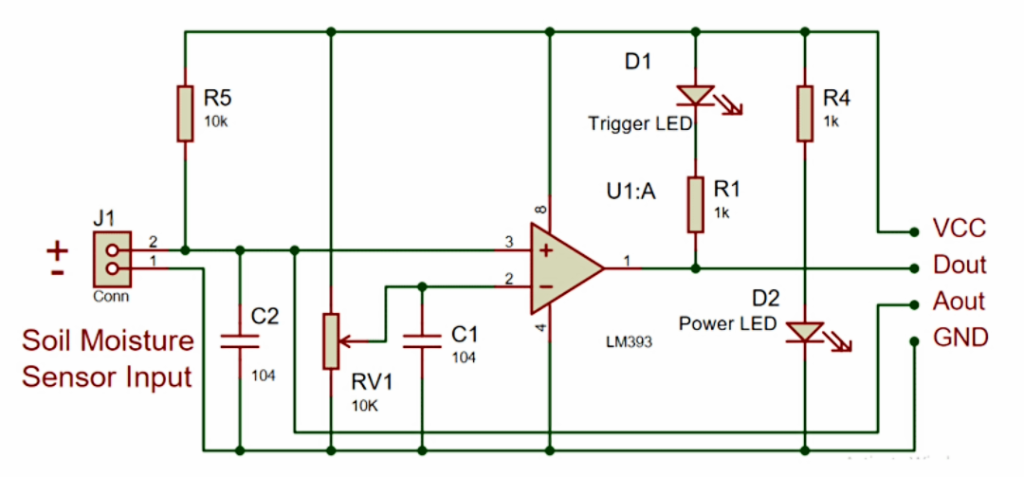

Using a Moisture sensor module with a microcontroller is very easy. Connect the Analog/Digital Output pin of the module to the Analog/Digital pin of Microcontroller. Connect VCC and GND pins to 5V and GND pins of Microcontroller. After that insert the probe inside the soil. When there is more water presented in the soil, it will conduct more electricity that means resistance will be low and the moisture level will be high.